1. Open **jupyter-examples-rel1.5.4 folder** -> open **configure.ipynb** -> copy the bastion username and paste it for FABRIC_BASTION_USERNAME [bastion user name can be found on the user profile page in the FABRIC portal (click "My SSH Keys")].   
   We need to create a bastion key. To create Bastion key go to FABRIC Portal -> Experiments -> manage SSH keys -> click on Bastion -> scroll down to generate Bastion key pair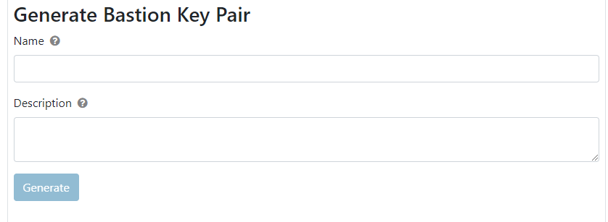

Write name (fabric_bastion_key) and description (can be anything) -> click Generate.

Download private and public keys after generating. (private key is important to download, it can’t be downloaded again)

Change FABRIC_PROJECT_ID -> the project ID can be found on the projects tab in the FABRIC portal

1. Go to **fabric_config folder** - > upload the private key which was fabric_bastion_key.
2. Go back to **configure.ipynb**. Set the path FABRIC_BASTION_PRIVATE_KEY_LOCATION. To find the location, go to the terminal. Type following commands  
   Cd fabric_config/ (to open folder fabric_config)  
   realpath fabric_bastion_key ( to get the path of fabric_bastion_key)  
   Copy the path and paste after export FABRIC_BASTION_PRIVATE_KEY_LOCATION=${HOME}.
3. Run each cell in the configure python file.